**From:** Kok Meng Lee (kokmenglee) [CONT - Type 2] [mailto:kokmenglee@micron.com]   
**Sent:** Thursday, 04 January, 2018 11:21 AM  
**To:** Chan, Pei-Fong  
**Cc:** Marcus, Tong  
**Subject:** RE: [EXT] RE: SKH Log issue 18 Dec 17

Hi Pei Fong

Suggested to input the indication as “ TBA” for split lot not required shipment order.

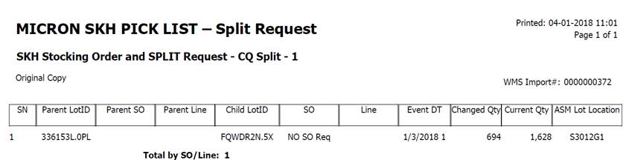

Thanks & Best regards,

Lee Kok Meng (Mr)

SKH & VAS / Asst Supervisor

Contract Logistics/SCM, Operation

Schenker Singapore (Pte) Ltd

35, Greenwich Drive, Level 5

Singapore 533952

DID: +65 6394 4401

Email: [kokmenglee@micron.com](mailto:kokmenglee@micron.com)

WMS Update:

Import split – CQ

Child SO = TBA

